Measurement protocol Trilaterion / UWB

By Mark Schrauwen

Global planning 2

Monday 24th of August 2

Tuesday 25th of August 2

Setup 2

Setup description 2

Preparation 3

Optitrack 3

Pozyx 3

Test Measurements 3

Wheelchair 3

Global 3

Synchronization 3

Measurements 4

Filename name giving 4

Protocol 5

|  |  |
| --- | --- |
| Goals | 1. Check and verify the simulated trilateration algorithms 2. Check the influence of the wheelchair on trilateration algorithms 3. Check the best place to position an UWB tag on the wheelchair 4. Check the influence of the human body in the wheelchair on ranging & positioning 5. Check the influence of speed of the tag on localization and transmission 6. Learn to use the IMU system of Rienk (WMS) and do measurements: System WMS + Optitrack + UWB |
| When | 24-25 of August 2020, optionally stretch to the 26th of August |
| Where | Bewegingslab THUAS (see Figure 1) |
| Systems | * Optitrack system with 16 Flex 13 IR-camera’s passive IR-marker system * Pozyx Creator system, 4 Anchors and 1 Tag * Wheelchair System of Rienk |
| Data output | * Optitrack: C3D format, containing the coordinate of IR-markers * Pozyx: csv file output format * WMS: IMU data? |
| Hardware | * Optitrack:   + 4 single markers (4 for each Anchor)   + 2 rigid bodies (1 for the Tag and 1 for the Wheelchair) * Pozyx:   + Wood attachment for UWB anchors (need at least 20 cm of distance)   + Some kind of attachment of the TAG onto the wheelchair   + Synchronization IR-Leds   + Pozyx system   + Arduino receiver results * WMS: * Pen, paper, post-its * RC car * Rope to pull empty wheelchair * USB Battery pack * Ramp to introduce height differences during measurements |

# Global planning

## Monday 24th of August

|  |  |
| --- | --- |
| Morning | Setup the Optitrack system, 6 meter by 12 meter setup. |
| Midday | Test measurements and in the good case a start of the measurement protocol |

## Tuesday 25th of August

|  |  |
| --- | --- |
| Morning | Do measurement as described in the measurement protocol (see below) |
| Midday | Do combo measurements with WMS |

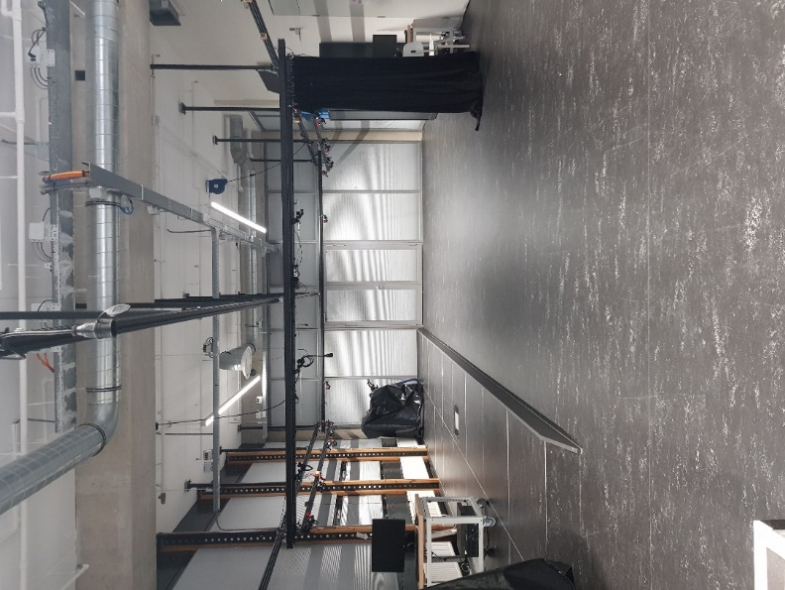

Figure 1: the Bewegingslab Optitrack system

# Setup

## Setup description

Figure 2: the UWB system setup. The Arduino and the Tag connected to it, are solely used for data transmission.

* Pozyx data is collected via Arduino MEGA (interface for Pozyx) which is connected to laptop (see: Figure 2) and datastream is logged with Coolterm
  + The laptop is placed on the WC
* Optitrack data is collected via Motive (Optitrack software) and exported each measurement in C3D format)
* RC car for LOS tag-movement (Figure 4)
* The Pozyx system comes with 2 options: FAST UWB ranging and PRECISE UWB ranging. Both consist of DS-TWR, but the FAST tries to optimize the number of measurements.

## Preparation

### Optitrack

1. Setup the Optitrack system
2. Extend the volume capture space (VCS) to a 6 x 12 meter
3. Calibrate the system
   1. Make picture of ground base to know the coordinate system
4. Test the system with a rigid body for spots with missing markers and adjust accordingly
5. Optionally: create a rigid body in the software for the Wheelchair and the Tag

### Pozyx

1. Place the anchors in the corners of the VCS with at least 20 cm distance from metal. Place anchors vertical
   1. Place 2 diagonal anchors ‘high’ (see Figure 5)
   2. Place 2 off-diagonal anchors ‘low’
2. Place on each anchor an Optitrack marker and make sure they are clearly visible in the software
   1. Note the coordinates of the respective anchors via Optitrack on paper with their hex id’s (used for Pozyx positioning)
3. Connect the power to the anchors
4. Test the tag for missing samples and try to improve this

### Test Measurements

1. Setup the RC-car and check it
2. Perform test measurements and check the results

### Wheelchair

1. Place several IR-markers on the wheelchair (WC), see Figure 3
2. Make a rigid body of it in Motive

### Global

1. Mark the path as visualized in Figure 5 on the floor

|  |  |  |
| --- | --- | --- |
|  |  |  |
| Figure 3: wheelchair planned to use in measurements | | |

# Synchronization

The synchronization of measurements will be done with an active Optitrack marker, made by 4 850nm IR-leds connected to the Arduino MEGA which will be turned on as soon as the measurements are logged.

# Measurements

## Filename name giving

In the table below the naming convention is given. Every category is separate by an underscore.

|  |  |  |  |  |
| --- | --- | --- | --- | --- |
| **Ranging** | RANG |  | **Random path** | (~) |
| **Pozyx positioning Fast** | PFST |  | **Predefined path** | (K) |
| **Pozyx positioning Precise** | PISE |  | **Standing still** | (S) |
|  |  |  |  |  |
| **WCS** | W |  | **Herre 3 Tags** | HF3 |
|  |  |  | **Verification or Test measurements** | VT |
| **Use of RC car** | CAR |  |  |  |
| **Use of WC, tag on TOP** | WET |  |  |  |
| **Use of WC, tag on the Seat** | WES |  |  |  |
|  |  |  |  |  |
| **No person in WC** | O |  |  |  |
| **Person in WC** | I |  |  |  |
|  |  |  |  |  |
| **Number of measurements** | ## |  |  |  |
| **Extension of output file** | . |  |  |  |

|  |  |
| --- | --- |
|  |  |
| Figure 4: RC car used for LOS movement of the TAG | Figure 5: The path of the tag (red) relative to the UWB anchors (blue triangles) |

# Protocol

Every measurement:

* Should be repeated 3 times and last at least 1 minute.
* Should be checked for missing data and be rejected when too much missing data is present (more than 1 second).

|  |  |  |
| --- | --- | --- |
| # | Setup | Filename |
| 0 | **Test measurements** | TV_CAR_(S)_##. |
| 1 | **Ranging** standing still on random spot | RANG_CAR_(S)_##. |
| 2 | **Pozyx positioning fast** standing still | PFST_CAR_(S)_##. |
| 3 | **Ranging** with known path | RANG_CAR_(K)_##. |
| 4 | **Pozyx positioning fast** with known path | PFST_CAR_(K)_##. |
| 5 | **Ranging** with random path | RANG_CAR_(~)_##. |
| 6 | **Pozyx positioning fast** with random path | PFST_CAR_(~)_##. |
| 7 | **Ranging standing still** for Rigid Body Matching Algorithm of Herre Faber | RANG_CAR_(S)_HF3_##. |
| 8 | **Ranging** with random pathfor Rigid Body Matching Algorithm of Herre Faber | RANG_CAR_(~)_HF3_##. |
|  |  |  |
| 9 | **Ranging** with known path with WC on top | RANG_WET_(K)_O_##. |
| 10 | **Pozyx positioning fast** known path with WC on top | PFST_WET_(K)_O_##. |
| 11 | **Ranging** with random path with WC on top | RANG_WET_(~)_O_##. |
| 12 | **Ranging** with known path with WC on the seat | RANG_WET_(K)_O_##. |
| 13 | **Pozyx positioning fast** with WC on the seat | PFST_WET_(K)_O_##. |
| 14 | **Ranging** with random path with WC on the seat | RANG_WET_(~)_O_##. |
| 15 | Combine with WCS, Ranging with known path | W_RANG_CAR_(K)_I_##. |
| 16 | Combine with WCS, Pozyx positioning with known path | W_PFST_CAR_(K)_I_##. |
| 17 | Combine with WCS, Ranging with random path | W_RANG_CAR_(~)_I_##. |